Northampton Association of Education and Industry
Class Constitution Worksheet

What rights and responsibilities do the citizens of your class need to have?

Constitution for Our Class

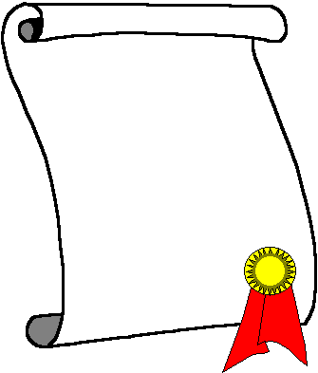

Rights  __________________  __________________  __________________  __________________  __________________  __________________  __________________  __________________  __________________  __________________ | Responsibilities  __________________  __________________  __________________  __________________  __________________  __________________  __________________  __________________  __________________  __________________

