Northampton Association of Education and Industry
Rights and Responsibilities Worksheet

What main rights and responsibilities are identified in each of these important documents?

Constitution of the Northampton Association of Education and Industry

Rights  __________________ __________________  __________________ __________________  __________________ __________________  __________________ __________________ | Responsibilities  __________________ __________________  __________________ __________________  __________________ __________________  __________________ __________________
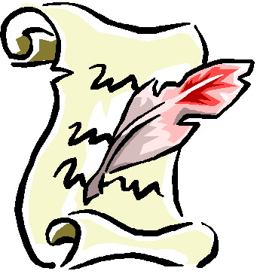
U.S. Constitution and Bill of Rights

Rights  __________________ __________________  __________________ __________________  __________________ __________________  __________________ __________________ | Responsibilities  __________________ __________________  __________________ __________________  __________________ __________________  __________________ __________________

State Constitution

Rights  __________________ __________________  __________________ __________________  __________________ __________________  __________________ __________________ | Responsibilities  __________________ __________________  __________________ __________________  __________________ __________________  __________________ __________________

